Windows firewall logs analysis.
To monitor, analyse, and understand network traffic behaviour using Windows Firewall logs for detecting suspicious or malicious activity

- Why and When Firewall Logging is Useful.

- To verify if newly added firewall rules work properly or to debug them if they do not work as expected

- To determine if Windows Firewall is the cause of application failures — With the Firewall logging feature you can check for disabled port openings, dynamic port openings, analyse dropped packets with push and urgent flags and analyse dropped packets on the send path.

- To help and identify malicious activity — With the Firewall logging feature you can check if any malicious activity is occurring within your network or not, although you must remember it does not provide the information needed to track down the source of the activity.

- Outgoing connections coming from internal servers such as Web servers could be an indication that someone is using your system to launch attacks against computers located on other networks.

Create the log file:

First of all, open windows defender firewall,
then, go for the properties option.
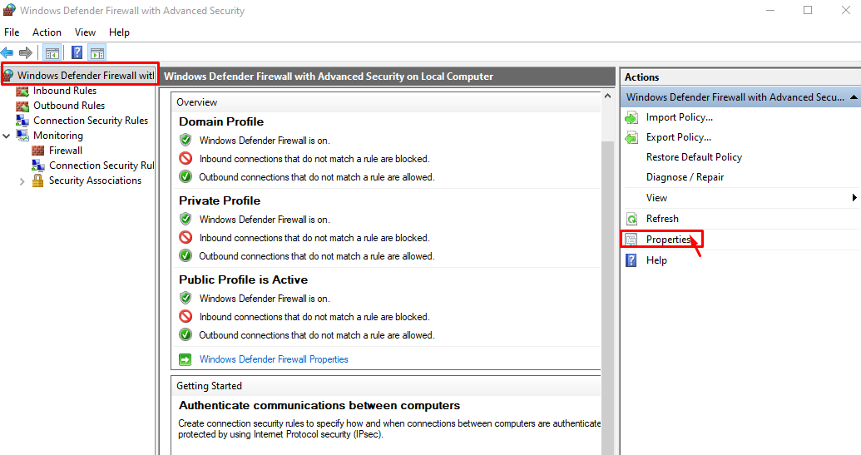

Then, go to the domain profile, logging customise option.
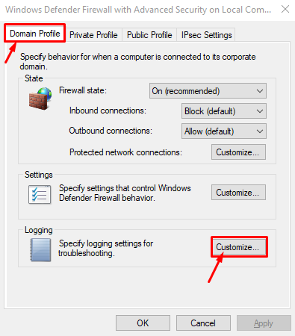
Then, change to Yes in those options then click ok.
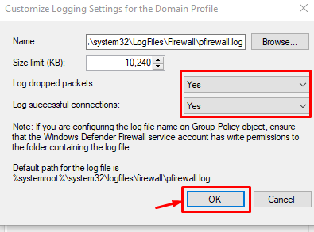

Remember,
Do the same for the other two private profile and public profile options.

Now, checking all of the settings.
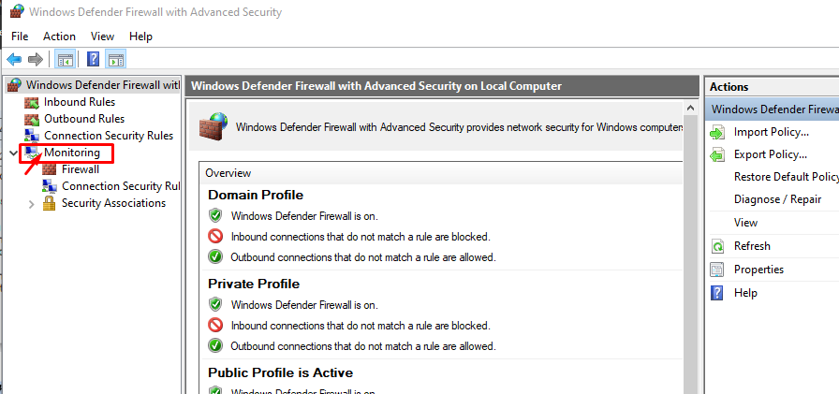

Go to the Monitoring option then logging settings.
If you check log activities click the file path then open a file and you can see all of the logs.

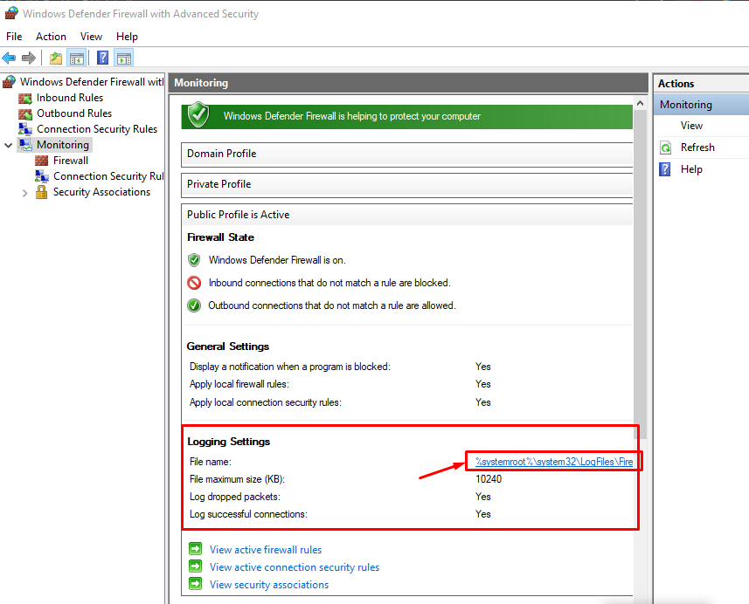

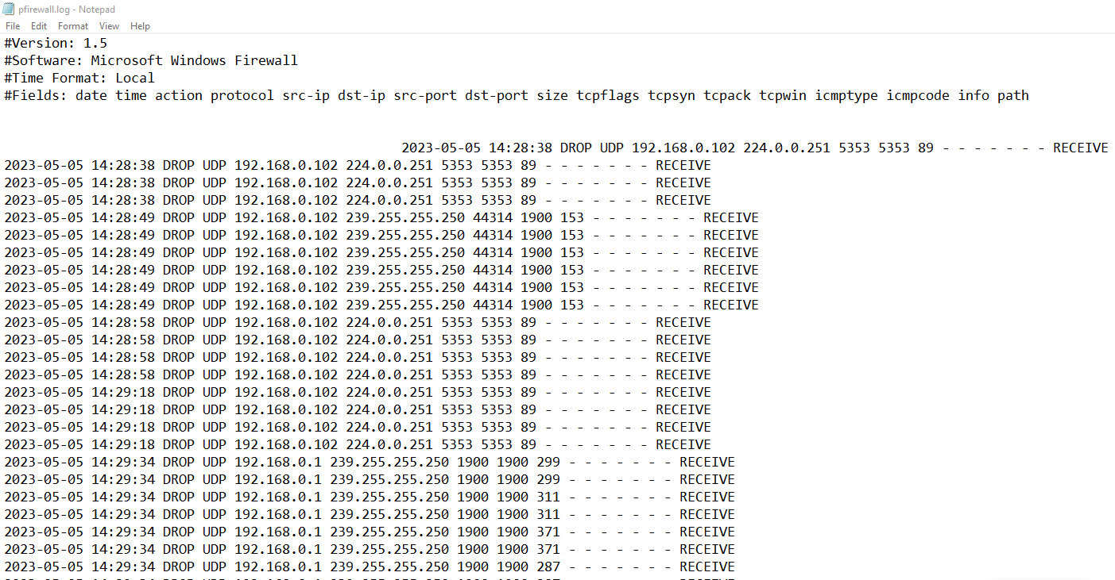
And you can save this file into notepad or go to the c drive then windows then system32 then log files then firewall then open pfirewall.log

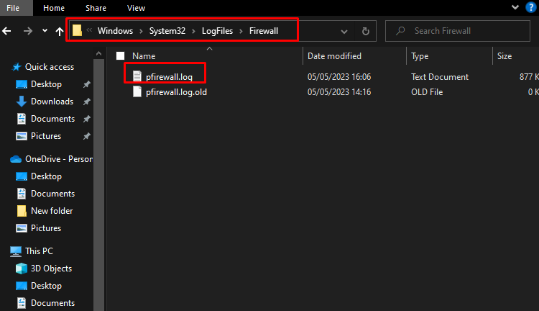

Windows firewall inbound rules making:

Go for the inbound rules option then you can see all rules on your windows firewall input tables. Now, you can also create new rules for your firewall inbound rules so click the new rules option.
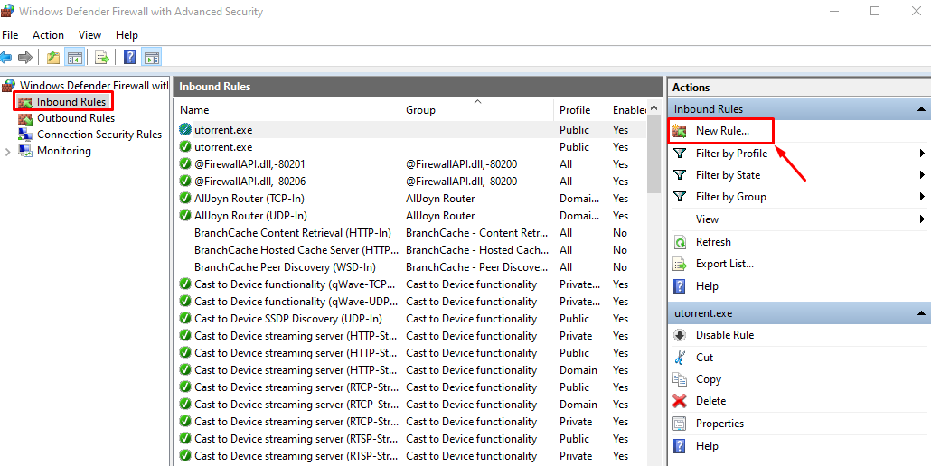
Rules type:

I used Port type rules.
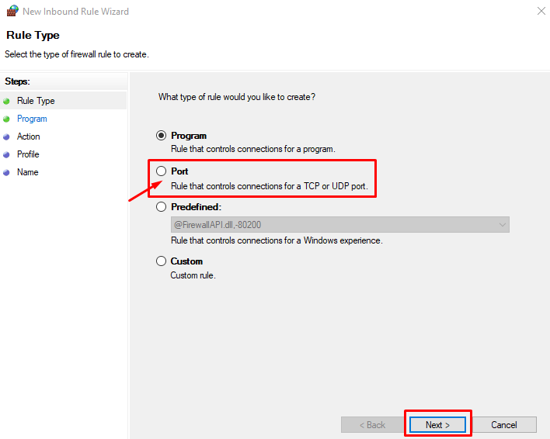

Used TCP ports and specifics ports
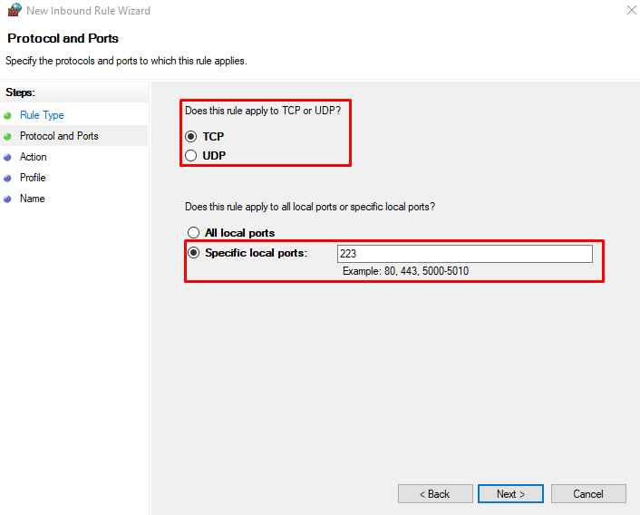

I used - block the connection.
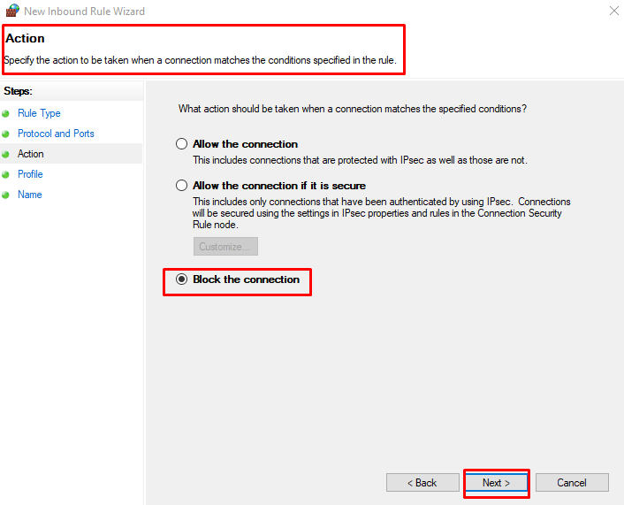

Now, set your desired profile that you want to blocked.
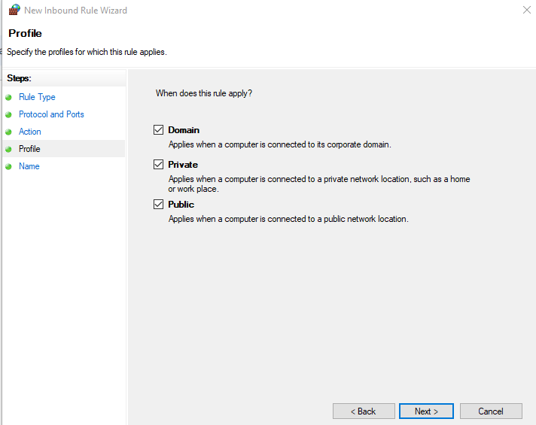

Set name.
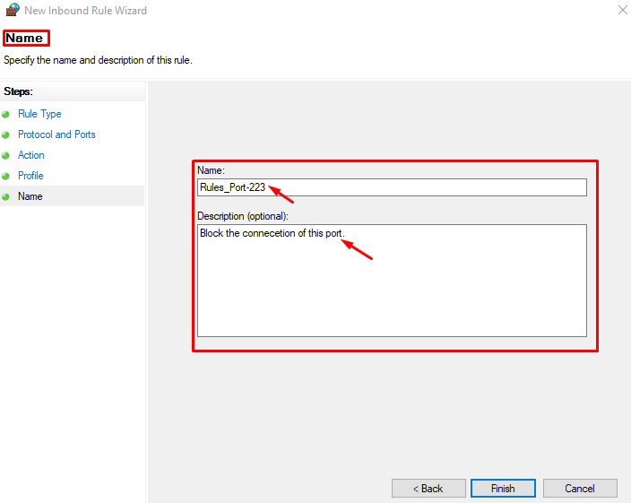

Now, inbound rules are perfectly make.
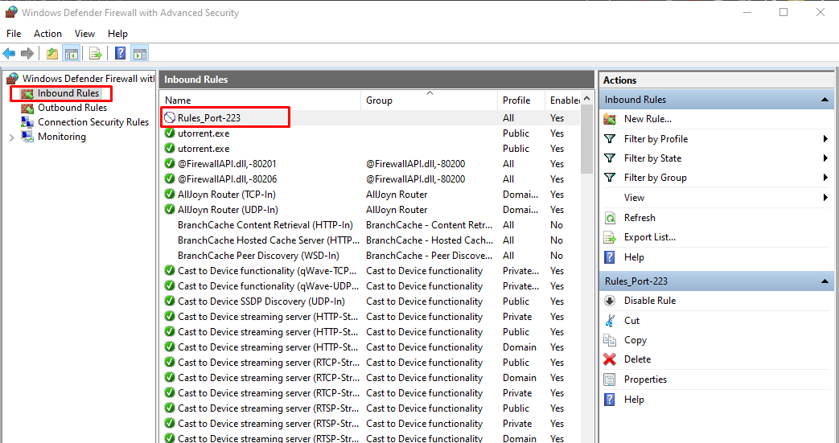

Windows firewall outbound rules making:

Actually, the procedure is the same so I did not do the same process for the second time so I followed the inbound rules.

So, these are the outbound rules for Windows machines.
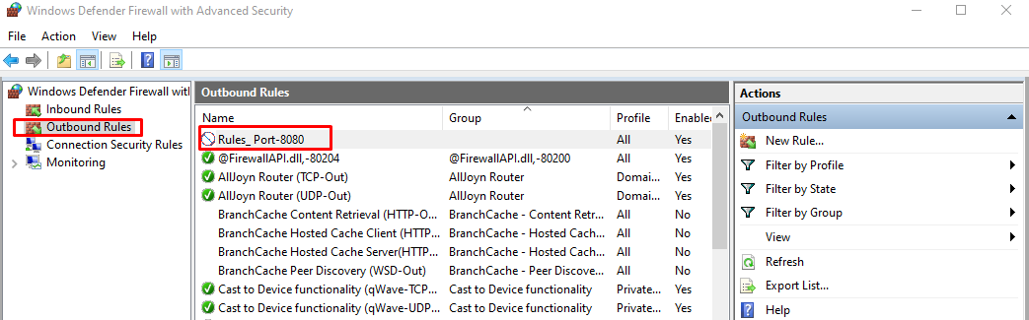

More firewall rules making:

Block and Allow any Website or Domain in Windows Firewall:

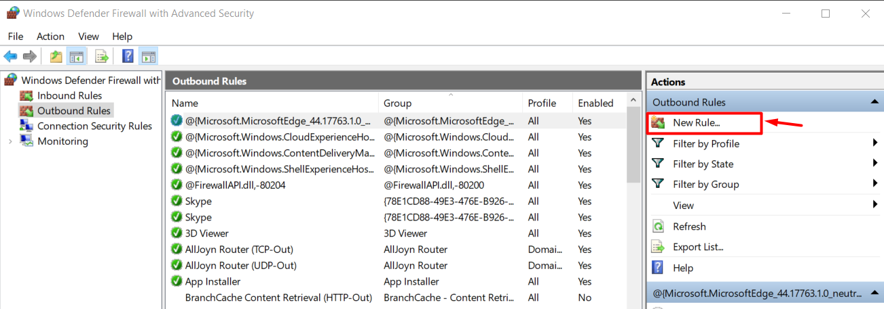

Choose - custom option then next.
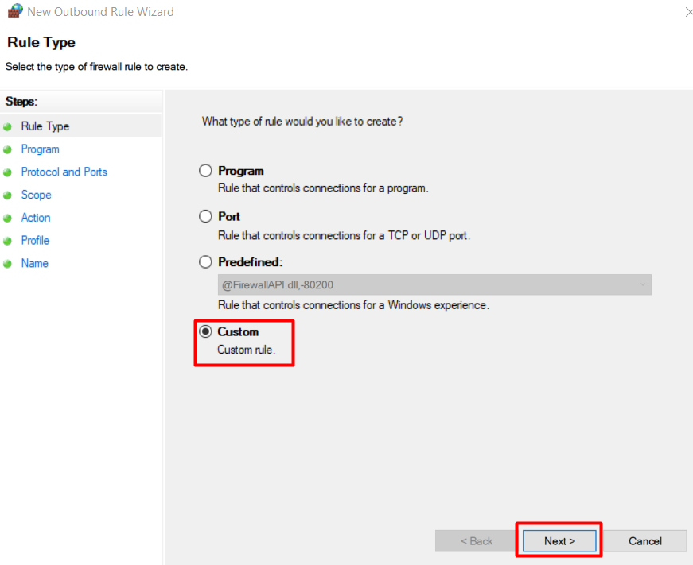

Select all programs.
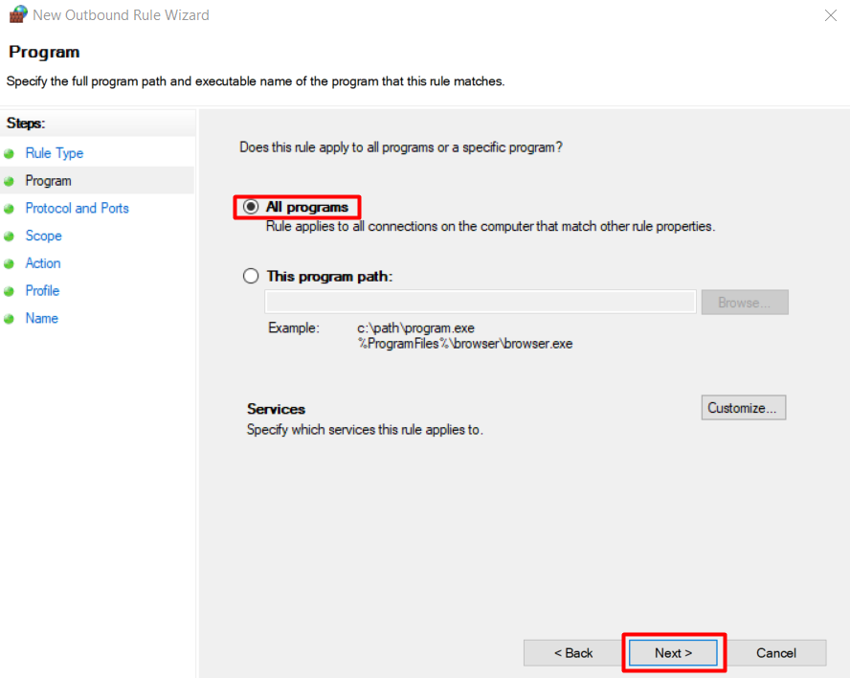

Then next.
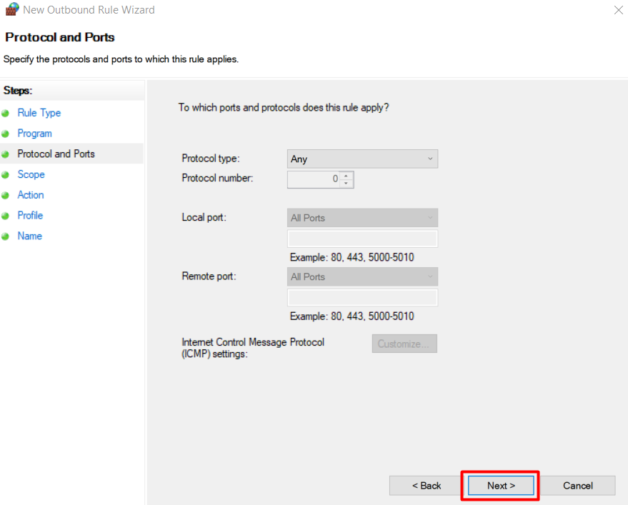

Then add the target website, such as, www.facebook.com
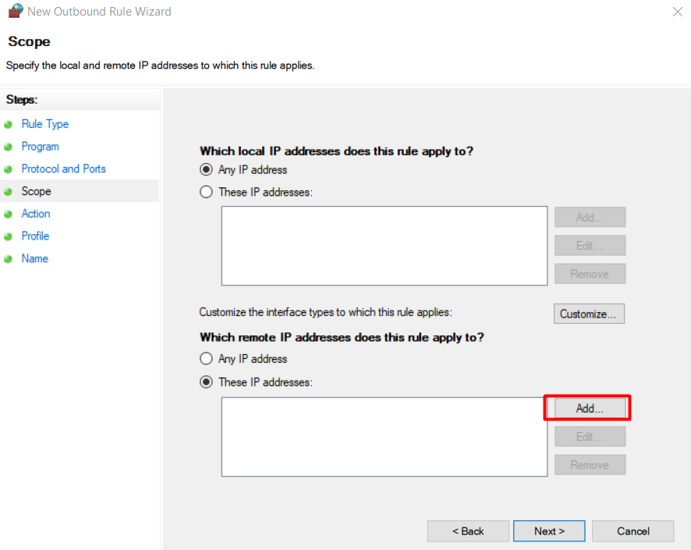

Access the website.
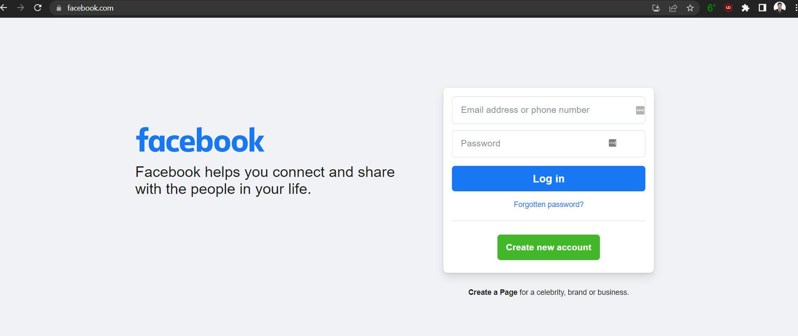

This is the ip address of facebook.com
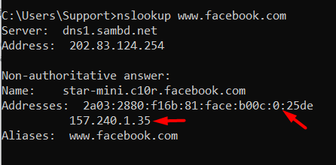

Put in those ip addresses.
First one is IPV6 and the other one is IPV4.
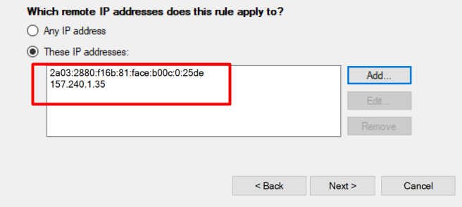

Block the connection.
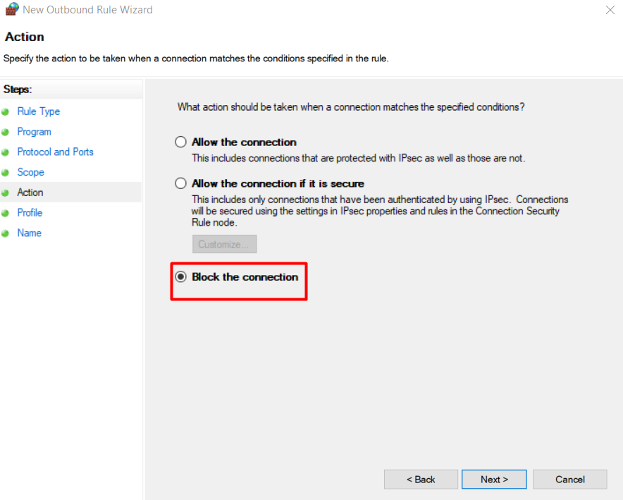

Now,
set your desired profile that you want to block.
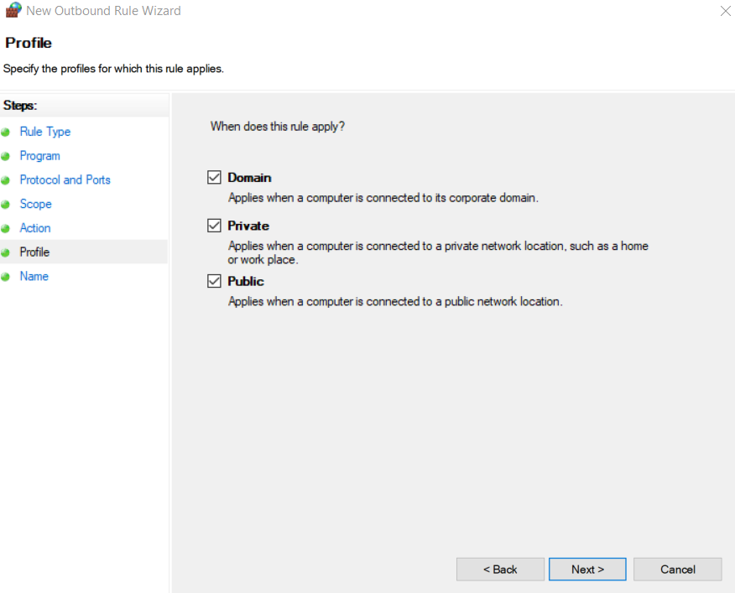
Give the name of this rules.
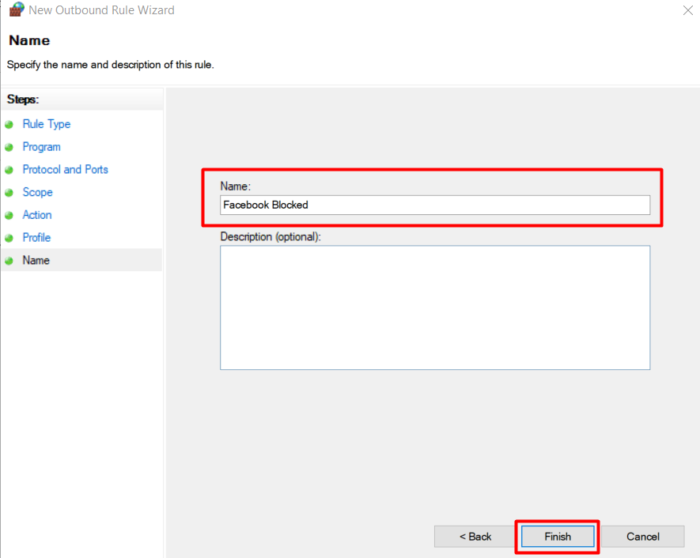

Successfully blocked the target website.
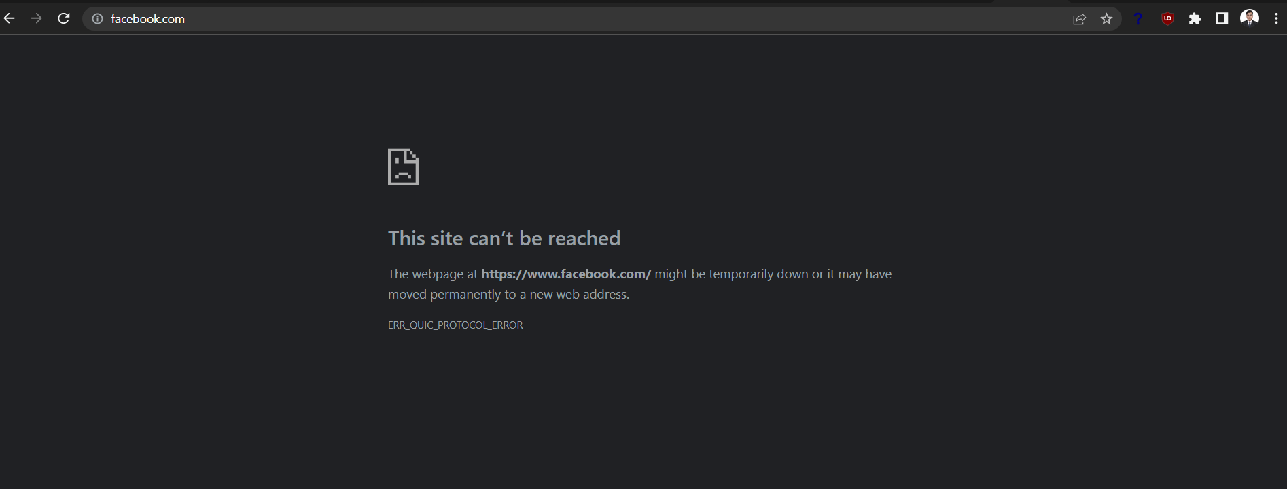

Block incoming ping using windows firewall:

Create inbound rules for blocking incoming ping.
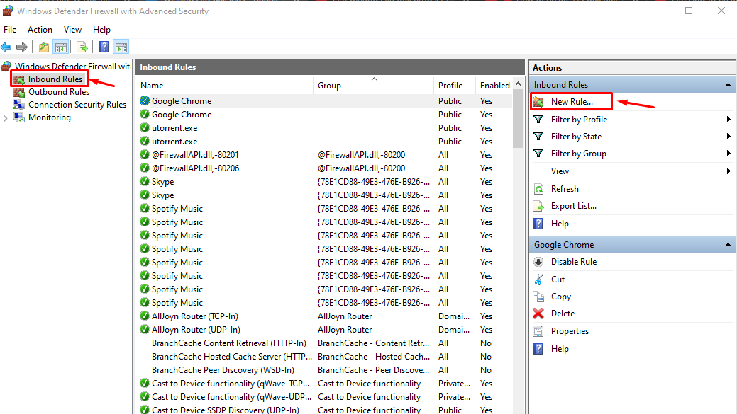

Select - custom option then next.
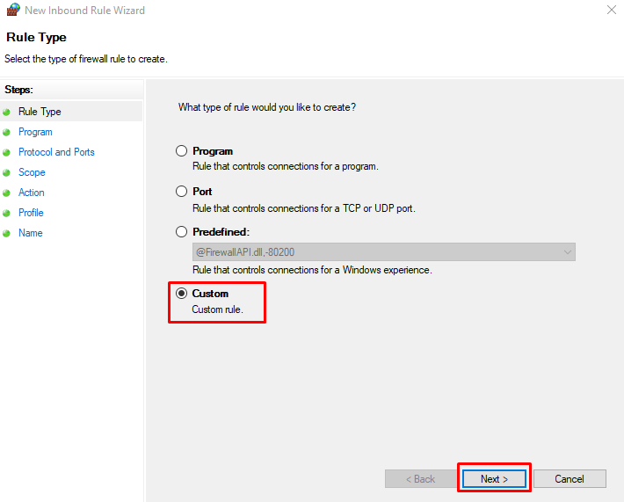
Choose all programs.
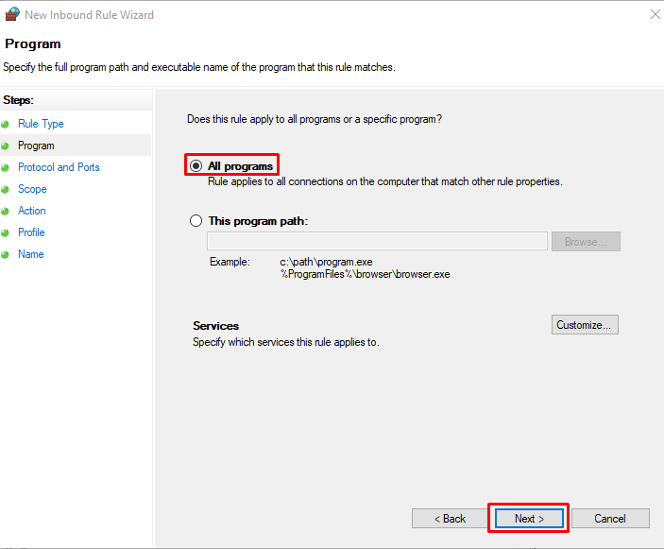

Select ICMP(Internet Control Message Protocol) then next.
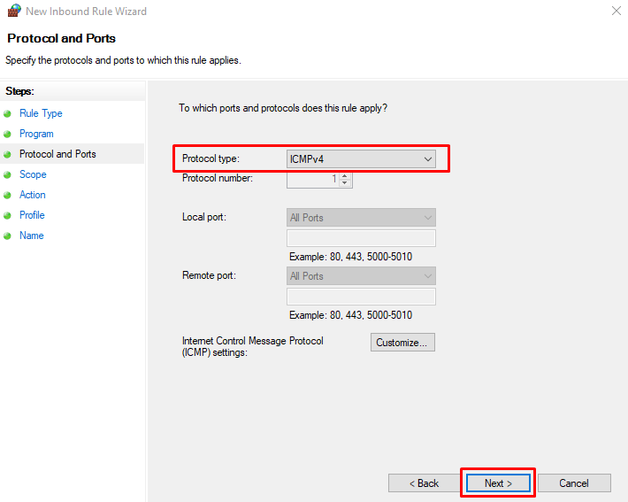

Nothing needs to be changed here, just go for next.
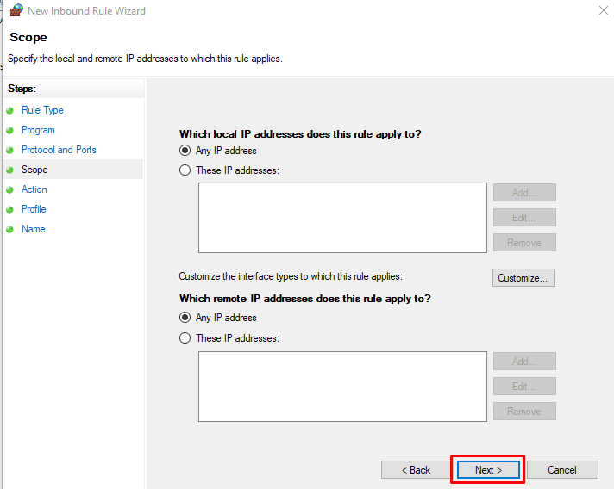

Select - Block the connection.
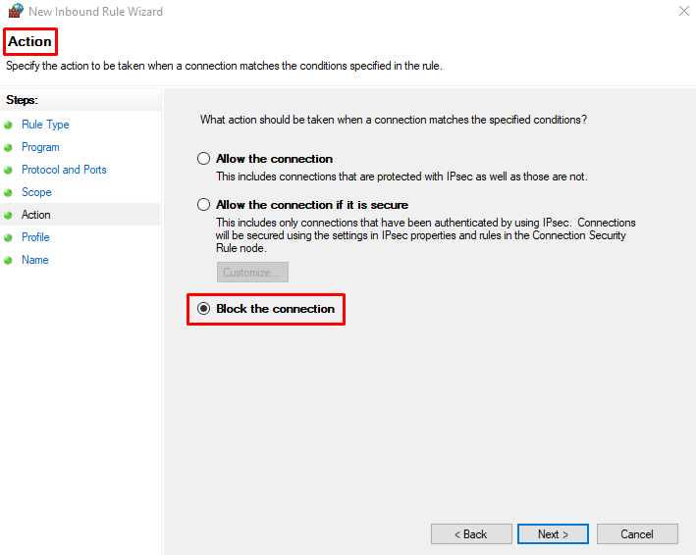
Check windows machine ip address.
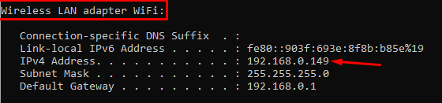

Trying to reach through ping and perfectly reachable.
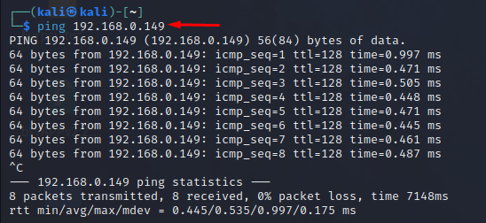

Now,
Set your desired profile that you want to block.
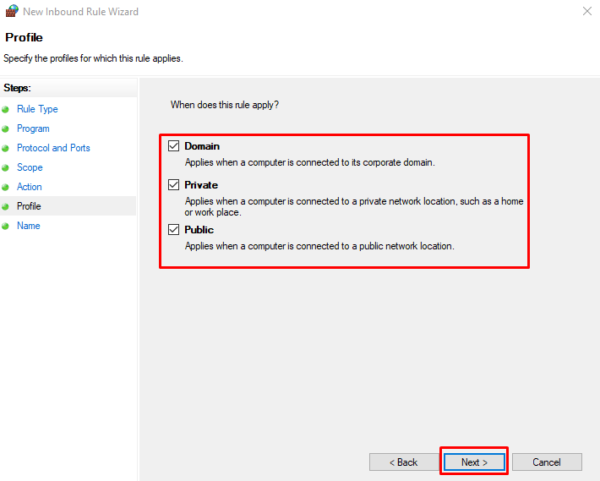
Offer the name of this rules then finish.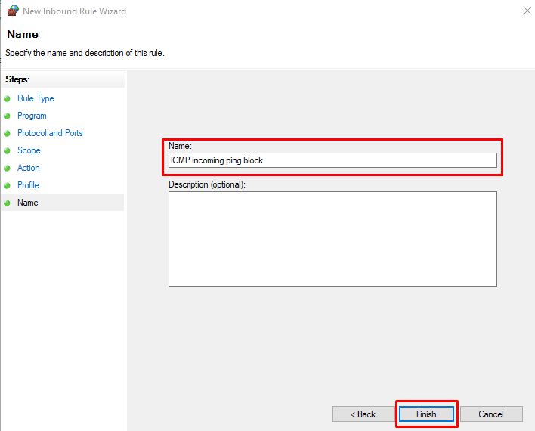

Here is the newly created rule.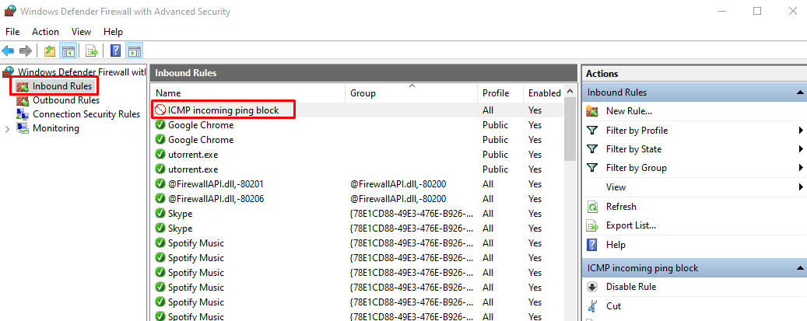

Windows firewall logs extraction:

Click the file path then open a file and you can see all of the logs.
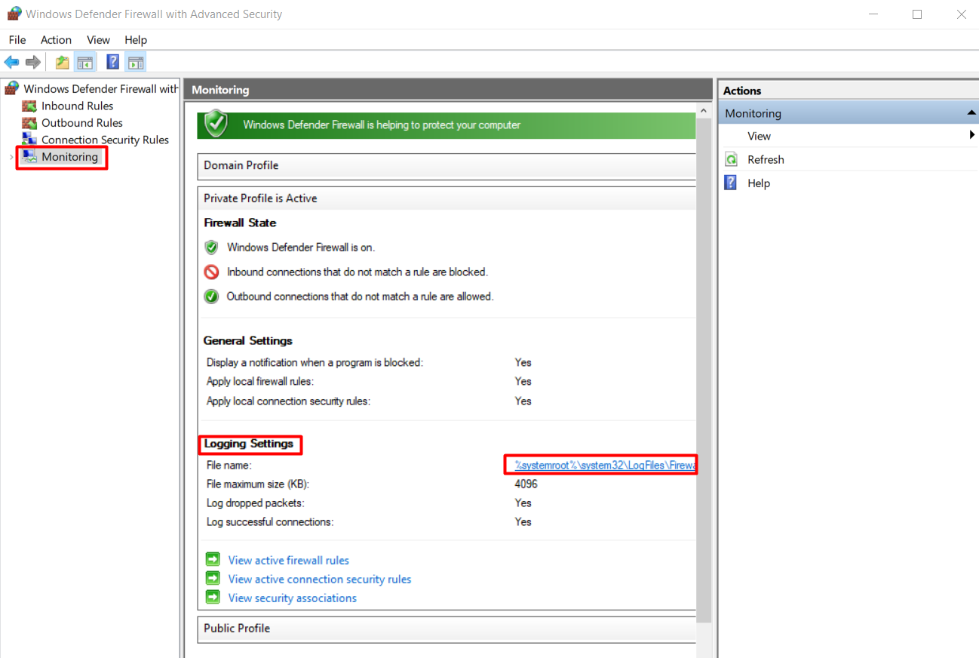

Here is all of the logs.


You can save this file by notepad.
Also you can access the log file in your personal computer, such as,
go to the C drive then windows then system32 then logfiles then firewall then open pfirewall.log



Identify rule engagement:

This is the log file of the firewall.
Now, I will find the rules that i was created before that actually works or not and also trying to recognize that rules on the firewall log file.

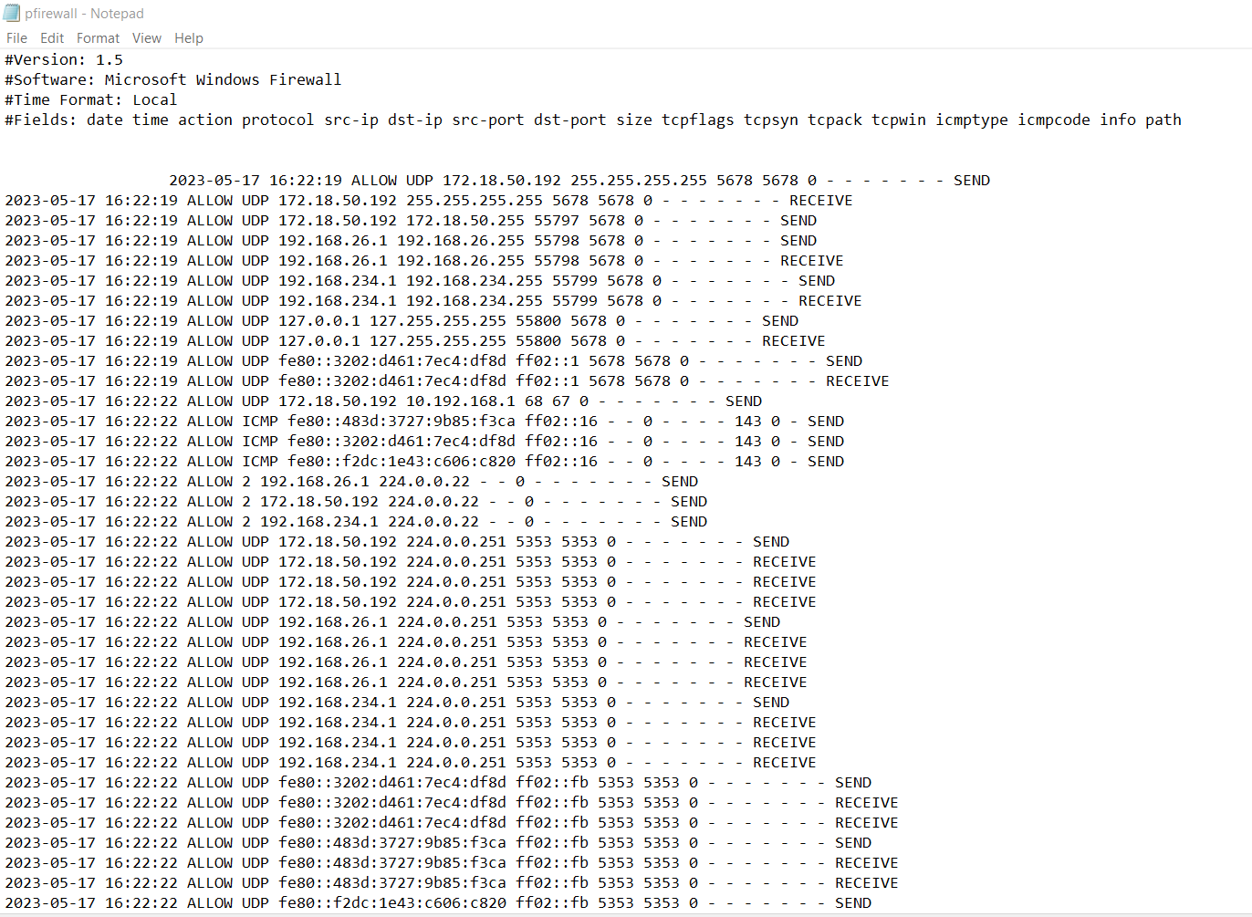

Find out the rules that are blocked.
The desired website is dropped.
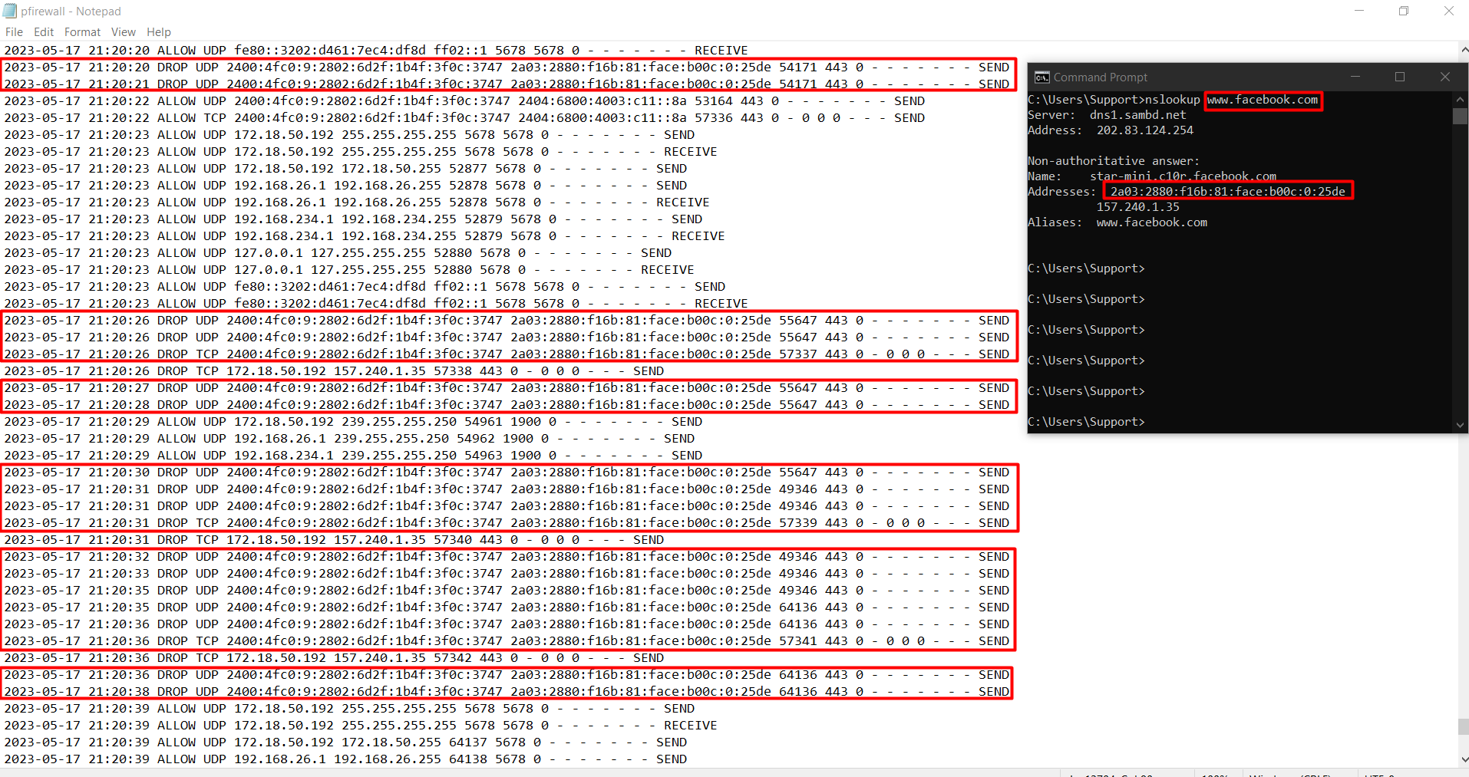

Thank you

